Language Notes Week Twenty-Five
Pull out Sign of the Beaver

Synonyms- words that mean the same, or almost the same as a word. Ex: shout and yell . Find synonyms for these words.

What reference book has synonyms?

genuine ________________________________________________
fuel ________________________________________________
massive ________________________________________________

Antonyms are words with an opposite meaning. Ex: sad and happy. Find antonyms for these words:

entered ________________________________________________
exact ________________________________________________
favorite ________________________________________________

Root – fract – to break or bend. Write a word for each picture using the root fract.
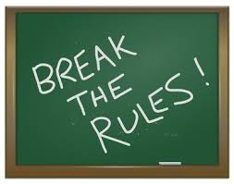
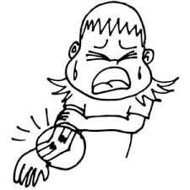
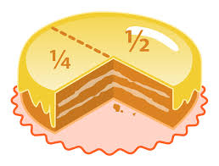

Week 25 Language Notes Continued

Preposition - show the relationship of a noun or pronoun to another word or words.
Example- The package is under the tree.

Commonly Used Prepositions
aboard | along | at | besides
about | along | because of | between
above | under | before | beyond
according to | among | behind | but
across | around | below | by
after | aside from | beneath | down
against | as of | beside | over

Turn to pg. 56. Find the paragraph starting with, “To Matt’s relief,”.

List five prepositional phrases in this paragraph. Circle the prepositions

________________________________________________________________________________________________________________________________________________________________________________________________________________________________________________

Write a sentence that contains a preposition and the word electrical. Circle the preposition.

Imperative sentences give a command. Write an imperative sentence containing the word err.

Homophones
word | part of speech | short sentence
your
you’re
medal
metal
would
wood

Idiom “On its last legs” - Something that is on ​its last ​legs is in such ​bad ​condition that it will ​soon be ​unable to ​work as it should: I would be glad to sell you my car, but I must tell you that it is on its last leg. Draw a quick picture of something on its last legs.

Comparative Adjectives
Adjective | Comparative Adjective | Superlative Adjective
long
 | happier
 | worse
important
 |  | Most boring

Find the comparative or superlative adjectives on the indicated pages. Identify the words they modify and what type of adjective it is.

Pg. 8
Adjective ________________, Word it Modifies _________________, Type of Adjective ___________________

Pg. 52
Adjective ________________, Word it Modifies _________________, Type of Adjective ___________________

Pg. 72
Adjective ________________, Word it Modifies _________________, Type of Adjective ___________________

Pg. 133
Adjective ________________, Word it Modifies _________________, Type of Adjective ___________________

